**Project Title:** Weather & Solar Energy Collection: AKA “Watt’s Up with Solar Energy”

**Team Members:** Brian Beck, Ashley Karlsson, Jack Langree,

Andrew Lindberg, and Kate Mikkelson

**Project Proposal:** Scrape historical data from personal home solar panels**.**

Get historical weather data from OpenWeather.

Combine datasets into a relational database to be used.

**Project Write-Up:**

* Sources of Data:
  + Minneapolis, MN solar panel API (SolarEdge) *JSON to CSV via API calls*
    - The notebook ‘solaredgePY_API-call’ was used to run API calls to the solaredge site. Care had to be taken to not breach the API call limits.
  + Ogilvie, MN solar panel API (Enphase) *CSV*
    - This was downloaded in bulk from Enphase’s monitoring site.
  + OpenWeather Historical Weather Data *CSV*
    - This was downloaded in bulk from OpenWeather for lat/long (44.9973, -93.2655) which is Northeast Minneapolis
* Transformations:
  + Cleaning timestamps by defining a timestamp function and setting up a list to loop through and apply the function to format all dates
  + Removing unnecessary columns from the weather dataset to reduce the amount of data stored in the final database.
  + Converting temperature from Kelvin to Fahrenheit
  + Converting data in the Minneapolis solar dataset from watts to watt hours and cumulative watt hours so both solar datasets contain the same information.
* Type of Final Database:
  + Relational database in PostgreSQL
  + The transformed datasets were loaded into the PostgreSQL database within Jupyter Notebook using SQLAlchemy.
* Final Tables or Collections:
  + The final tables in the database include solar data from Minneapolis (solar_minneapolis), solar data from Ogilvie (solar_ogilvie), and Minneapolis weather (weather).
  + The date field was used as the primary key to relate the weather and solar data tables.

**Breakdown of Work:**

Jack:

* Data transformation - Minneapolis Solar Panel Data
* Timestamp guru

Ashley:

* Data extraction of Ogilvie Solar Array
* Data transformation

Brian:

* Transformation of Weather Data
* Schema editing
* Portions of ETL writeup

Kate:

* Entity Relationship Diagram & Initial Schema Set-Up
* Documentation Set-up
* Puns

Andy:

* Data extraction of Minneapolis Solar Array
* Data transformation

**Git:** <https://github.com/alvern/ETL_solarpower_weather>

**Entity Relationship Diagram (ERD):**

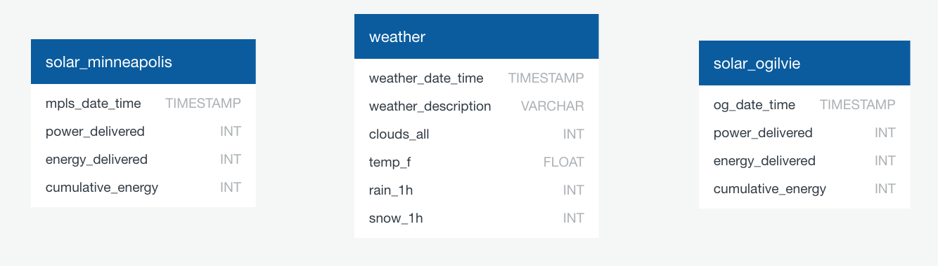

**Test Query Results:**

